写java等OOP语言时要有码形(Code&UML)结合的思想

什么是数据结构?
A：数据的存储和调用，为了数据的有效的存储和调用所以会涉及算法

what is token?
A：smallest individual unit in java , basically 5 types:
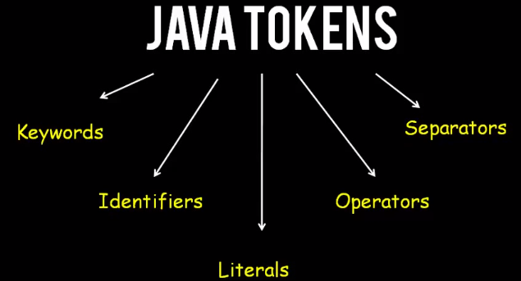
what is reference variable?
Reference variable a nothing but a variable which stores an object ,
if a variable is declared but not assigned with object it’s an non-reference variable

does variable consume memory space?
Yes , declear variable is reserving memory space for data to store in , the size reserved is according to the data type of variable.
even though if there is no data stored , but the memory space is still declear as reserved by that variable.
thus variable consumes memory space anyway.
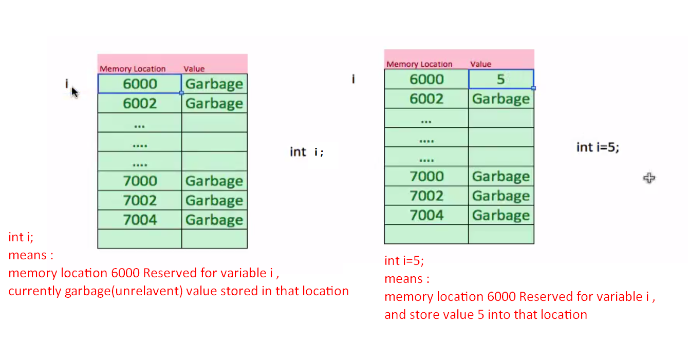
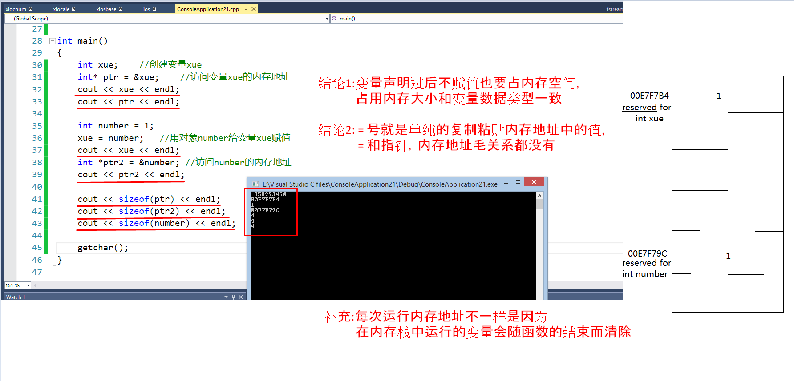

memory space calculation?

∵Memory size = address line number * memory storage per location
∵In real memory address line number is in binary format
&& address line number = 2^(bits number in memory address)

∴Memory size=2^(bits number in memory address) * memory storage per location

例:
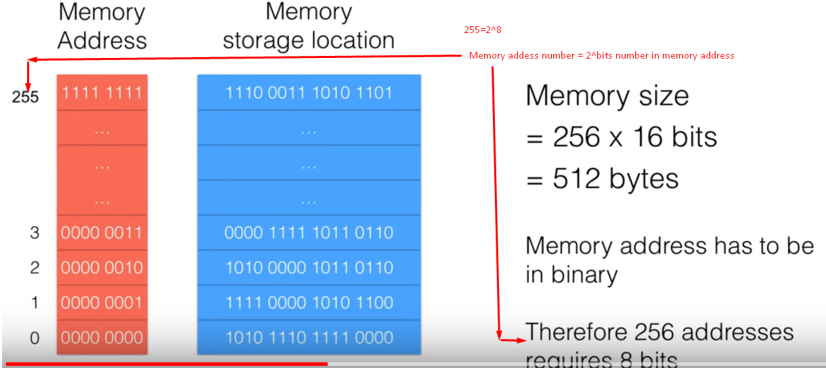
//2^7+2^6+2^5+2^4+2^3+2^2+2^1+2^0=255

what is hz?
image refreshing rate per second :
60hz per second means refresh 60 times/create 60 new images per second (that what makes image motions)

单位:
1Ghz=1000Mhz=10^6Khz=10^9hz
冯诺依曼计算机概念
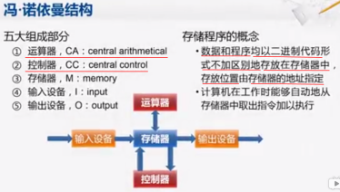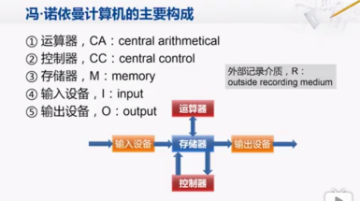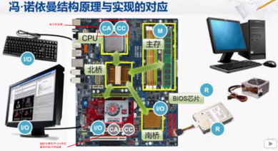
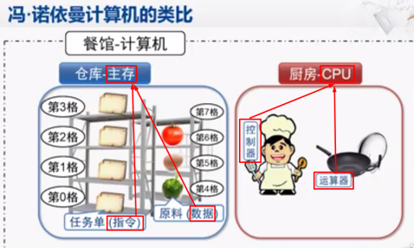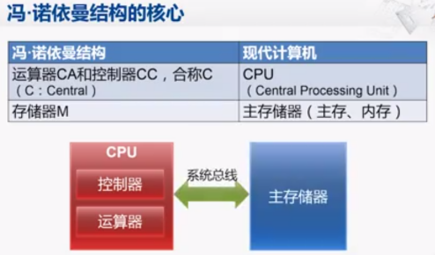

java关键字和操作符
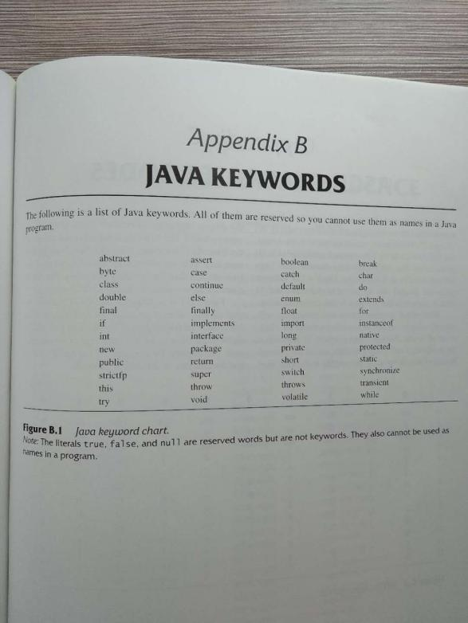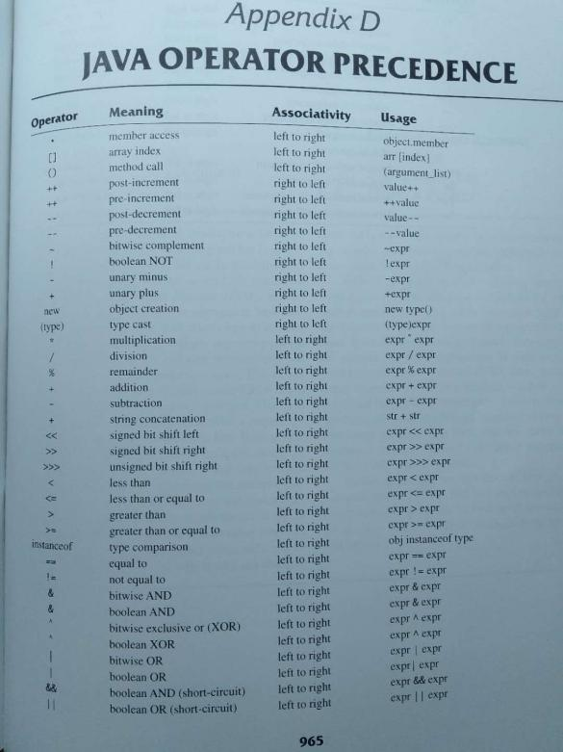

Debugger 和 breakpoints
- Breakpoint 是 Debug模式提供的的一个功能,

如果运行debug模式时不打断点的话程序会直接正常从头到尾地运行,
但是如果打了断点,Debug模式中程序会运行到断点时停止,
让你可以用f11进行单步调试程序,并且让你观察变量和函数的变化

//Debugger 可以用于观察较复杂程序的运行顺序和函数的调用顺序

